Ramsey and Washington counties, through Ramsey/Washington Recycling & Energy (R&E), are developing a new way to collect food scraps from residents so that they can be recycled. Recycling food scraps will provide health, environmental and economic benefits to the community. Here’s how it will work:

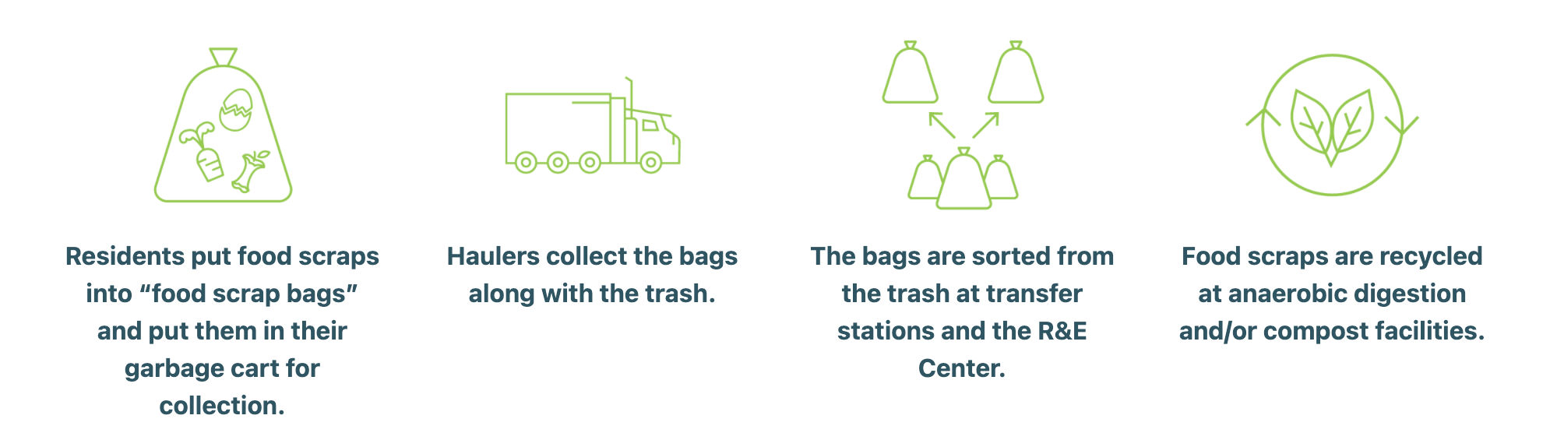
Food scrap bags are durable, compostable plastic bags that are designed to withstand being put into a garbage cart, transported in a garbage truck and sorted out afterwards. As part of program planning, R&E wants to replicate the process of food scrap bags going through the whole system, starting at residents’ garbage carts, to test the bags’ ability to be transported in the trash without breaking under various circumstances.

How will this test work?
To test the bags’ durability, staff will place pre-filled food scrap bags into Roseville residents’ garbage carts the morning of their normal garbage day (when the carts are at the street curb). Haulers will collect garbage as normal and bring it to the Recycling & Energy Center in Newport, where they will dump their trash in a special location in the facility so that we can assess how the bags withstood the transport process. The food scraps will be composted after the test is completed.
Who will be doing the test?
R&E, with the help of Foth Infrastructure and Environment and Walter’s Recycling & Refuse, will be conducting the bag test. Foth staff will use marked vehicles and wear safety vests as they place the food scrap bags into garbage carts on the street.
Where will the test be occurring?
R&E will work with Walter’s Recycling & Refuse to determine which Roseville streets their trucks will be collecting trash on the day of the test. Food scrap bags will be placed into randomly selected garbage carts on these routes that are at the street curb on that morning. Foth staff will not enter private property if a garbage cart is not out.
When will this be occurring?
The test will occur on Monday, April 26. Bags will be placed into garbage carts early in the morning on the day of the test prior to hauler collection.
Will residents be notified of the test?
Yes. Walter’s Recycling & Refuse will provide education via direct mail to households whose garbage carts may be randomly selected.
Will the test effect garbage collection?
No. Garbage will be collected by residents’ garbage haulers as normal. There will be no impact to residents whose garbage carts are randomly selected.
Who should I contact with additional questions?
Please call Walter’s Recycling & Refuse at 763-780-8464 or the Ramsey/Washington Recycling & Energy Center at 651-768-6670 with any additional questions.
What will the vehicles placing the bags into garbage carts look like?
Staff from Foth Infrastructure and Environment will be placing the bags into garbage carts using two vehicles. One is a gray pickup truck, pictured below, with a Foth logo on the front door. The second vehicle will be a rented pickup truck that will have a Foth logo affixed to the door using a magnetic label. A photo of the magnetic label is shown below.

